Name: Class:

Task 1
For each of the scenarios given below, tick which hacking techniques have been used. Underline the part(s) in the scenario that support(s) your choice. The first scenario has been completed as an example.
 | Scenario | Virus | Worm | Trojan | Ransomware | Adware | Spyware
1 | Tyler goes to a website that says that it will supply cracked software that doesn’t need a licence. After installing the software, the user is pleased as it works as expected. They notice later that many adverts display on their computer.
2 | Leila clicked on a file in an email attachment. Today, when she turned on her computer it said that all her files are now encrypted. She has been given 24 hours to pay one bitcoin to unencrypt the files.
3 | Richard has downloaded a file from the Internet and run it. After a short while he has noticed that many of the files on his computer have been deleted or corrupted.
5 | A program has been written that targets computers on the Internet. It automatically replicates itself, and whilst it doesn’t harm any individual computers, it does slow down the network.

Task 2
You have been asked to help a user that isn’t that knowledgeable about computer security.
In the table below are some actions that they commonly take. For each action, explain the security risk and what you would advise them to do instead. The first row has been completed for you.
Action taken by user | Security risk | Advice
The user ignores most app updates as sometimes the apps need a username and password to be entered again. | The software will be unpatched / have security issues that are not fixed | Update all apps/software
A user visits a legitimate looking website for their bank. The web address is very slightly different to usual. They enter their username and password to log in, but it says there is an error.
The user is very honest and helpful. They work as a receptionist. When someone phones and asks for information about other staff in the company, such as their full name, they are happy to help.

Task 3
Look at the following text message.
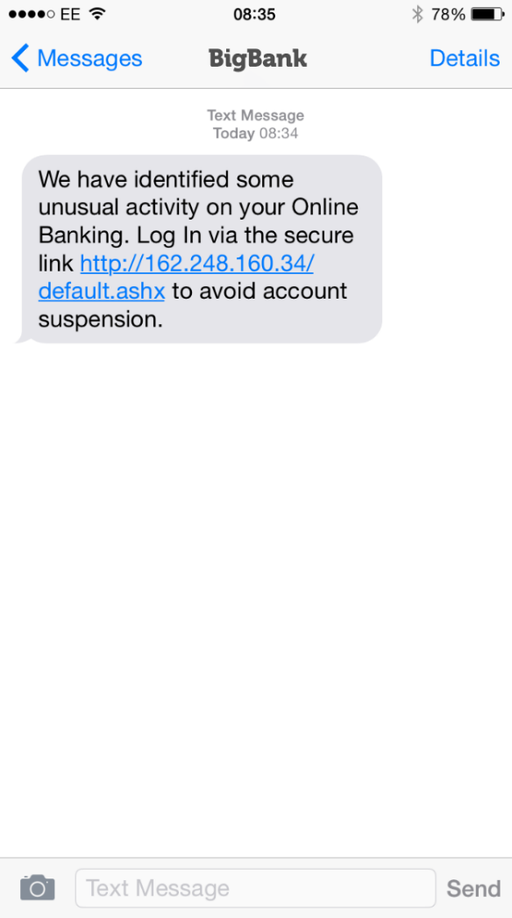
(a) What action should the recipient take?

(b) Give reasons for your answer:

Task 4
Draw a diagram to explain how pharming works. Write an additional explanation of how pharming works beneath the diagram.

Task 5
1. Carry out some research on Distributed Denial of Service attacks and write up your findings.
Be sure to include answers to the following questions.
- What is a DDoS attack?
- Who is typically targeted?
- Who does it typically affect?
- How can it be countered?

2. Research one or more examples of DoS attacks and write a short description. Cover the following points:
- When did it take place?
- Which country/organisation was affected?
- How many people were affected?
- Who was responsible for the attack?
- What were their motives?
- How was the attack accomplished?
- How can organisations protect themselves?
Sample websites:
https://www.metacompliance.com/blog/10-biggest-ddos-attacks-and-how-your-organisation-can-learn-from-them/
http://www.independent.co.uk/life-style/gadgets-and-tech/worlds-largest-denial-of-service-attack-caused-by-vulnerability-in-the-infrastructure-of-the-web-9122200.html

